AI Assisted Coding Lab ASS-11.1

Name:M.Mohan venkatesh
Batch:14
2303A510B1
Task Description #1 – Stack Implementation
Task: Use AI to generate a Stack class with push, pop, peek, and is_empty
methods.
Sample Input Code:
class Stack:
pass
Expected Output:
• A functional stack implementation with all required methods and
docstrings.

PROMPT:
#Generate a clean, well-documented Python Stack class using a list with push, pop, peek, and is_empty methods, proper error handling, comments, and example usage.
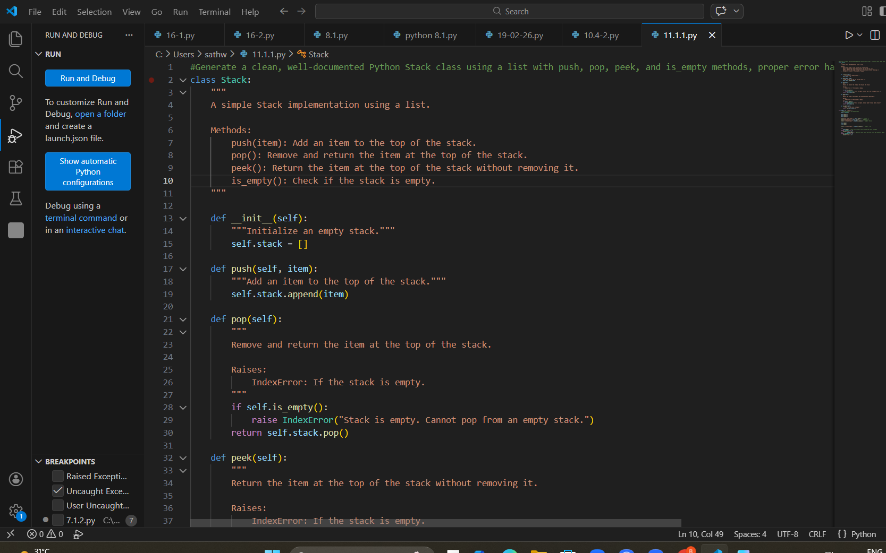
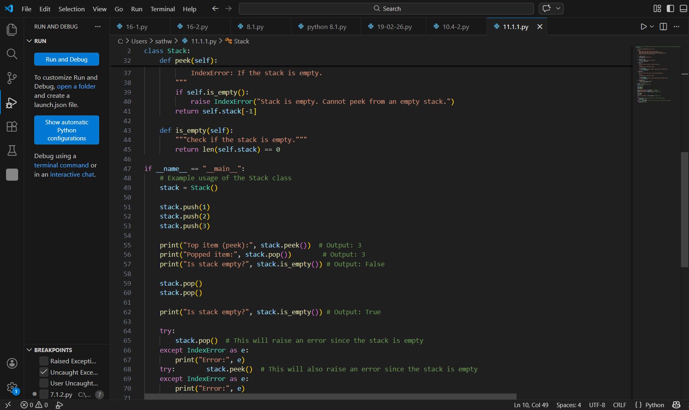

OUTPUT:
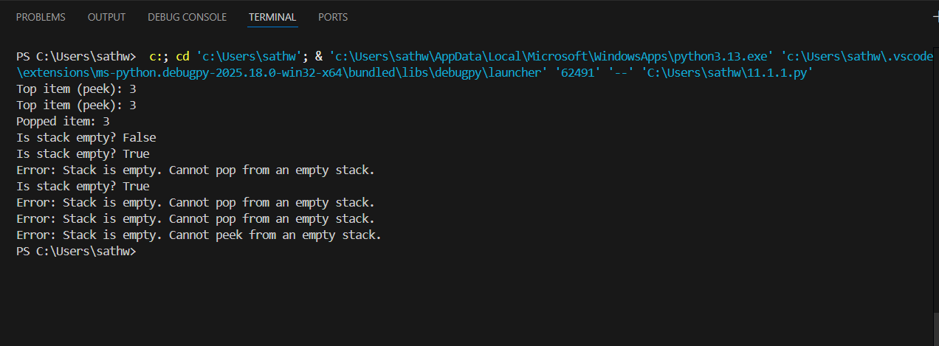

Task 1 – Stack
Justification:
Stack follows the LIFO principle, where the last inserted element is removed first. It is useful in undo operations, recursion, and expression evaluation.

Task Description #2 – Queue Implementation
Task: Use AI to implement a Queue using Python lists.
Sample Input Code:
class Queue:
pass
Expected Output:
• FIFO-based queue class with enqueue, dequeue, peek, and size
methods.
PROMPT:
Create a FIFO-based Python Queue class using a list with enqueue, dequeue, peek, and size methods, including docstrings, comments, and example usage.

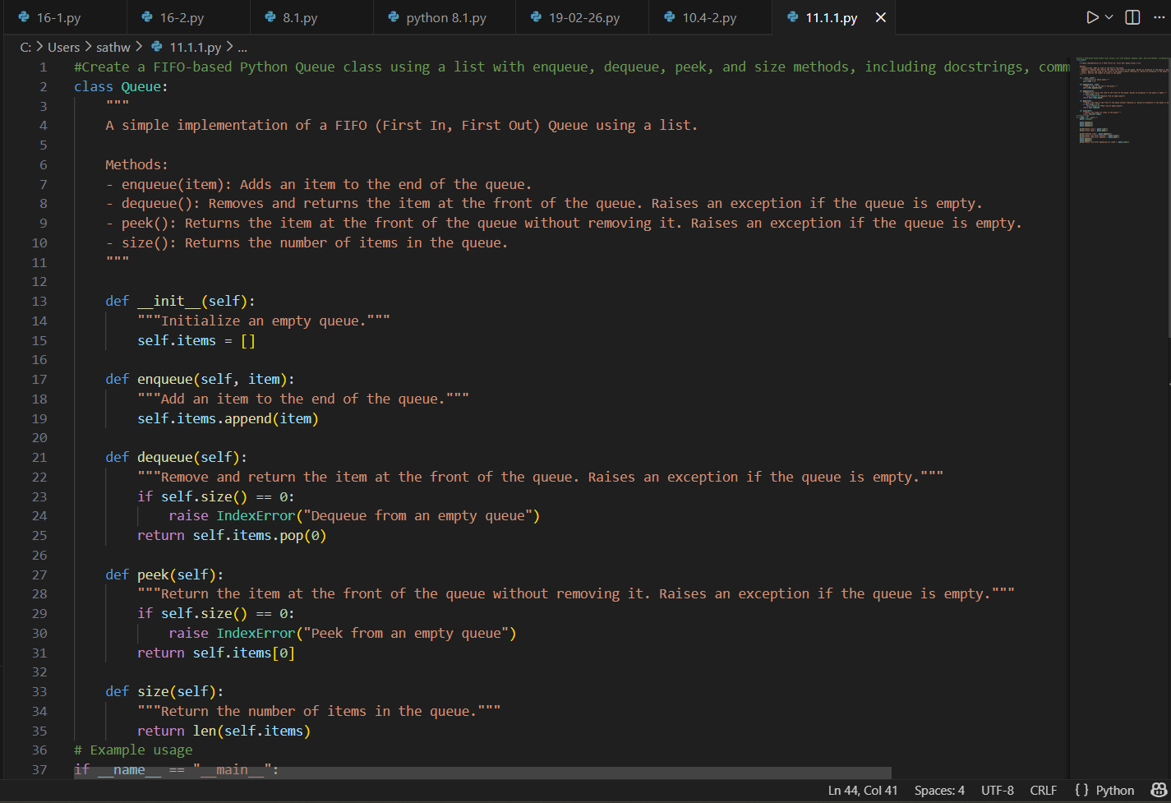
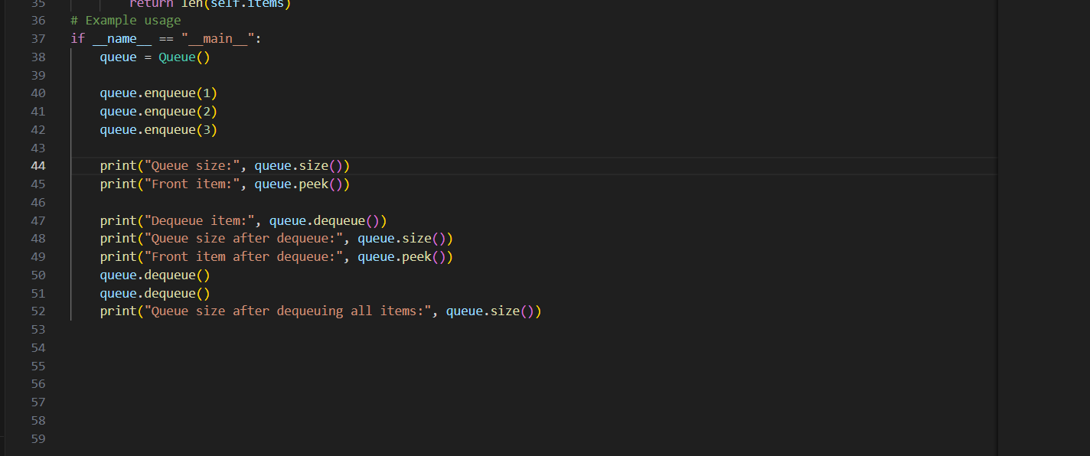
OUTPUT:
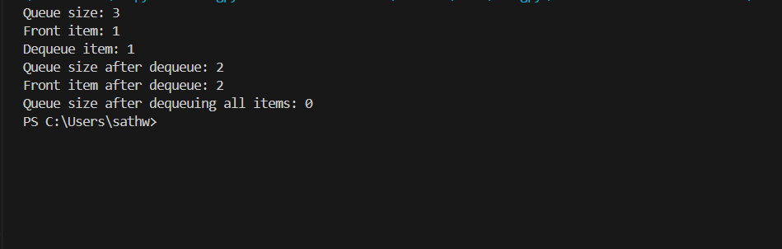
Task 2 – Queue
Justification:
Queue follows the FIFO principle, where the first inserted element is removed first. It is commonly used in scheduling and real-time processing systems.

Task Description #3 – Linked List
Task: Use AI to generate a Singly Linked List with insert and display
methods.
Sample Input Code:
class Node:
pass
class LinkedList:
pass
Expected Output:
• A working linked list implementation with clear method
documentation.

PROMPT:
#Generate a Python implementation of a Singly Linked List with Node and LinkedList classes including insert and display methods, proper documentation, comments, and example usage.

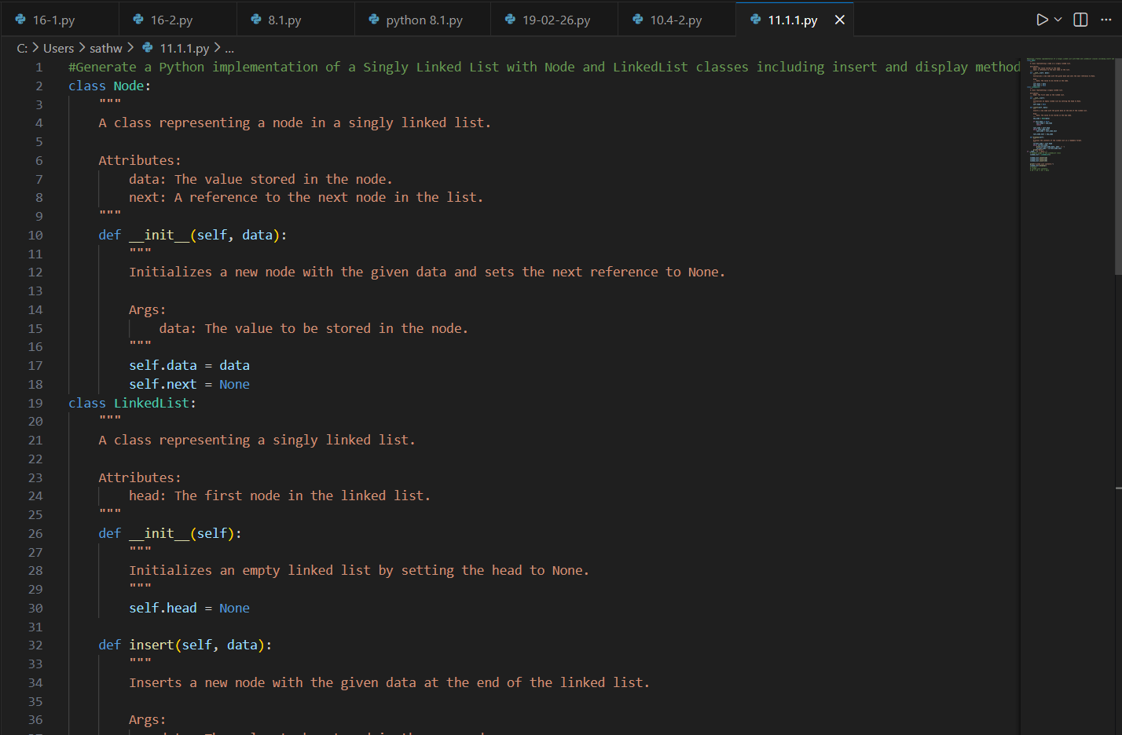
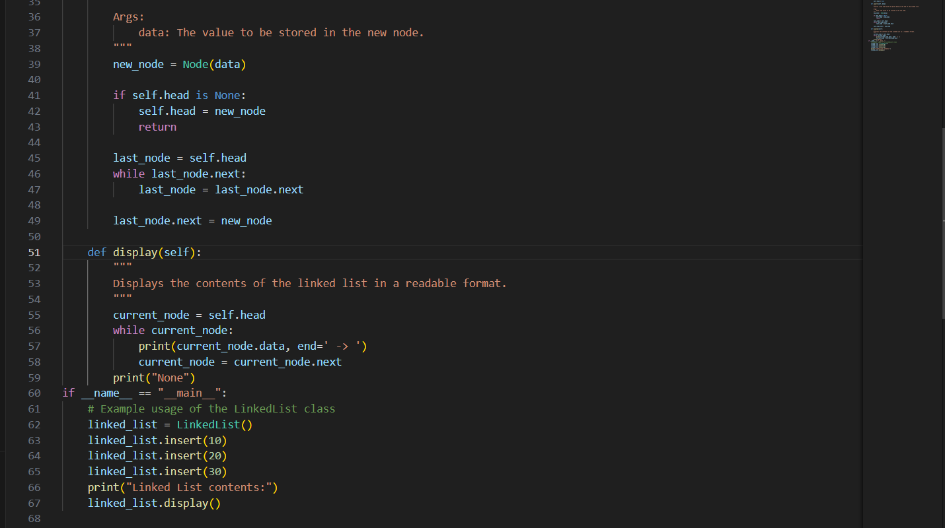

OUTPUT:
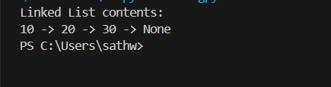
Task 3 – Linked List
Justification:
Linked List allows dynamic memory allocation and easy insertion or deletion. It is useful when the size of data changes frequently.

Task Description #4 – Binary Search Tree (BST)
Task: Use AI to create a BST with insert and in-order traversal methods.
Sample Input Code:
class BST:
pass
Expected Output:
• BST implementation with recursive insert and traversal methods.

PROMPT:
#Create a Python Binary Search Tree with recursive insert and in-order traversal methods, maintaining BST properties, with docstrings, comments, and example usage.
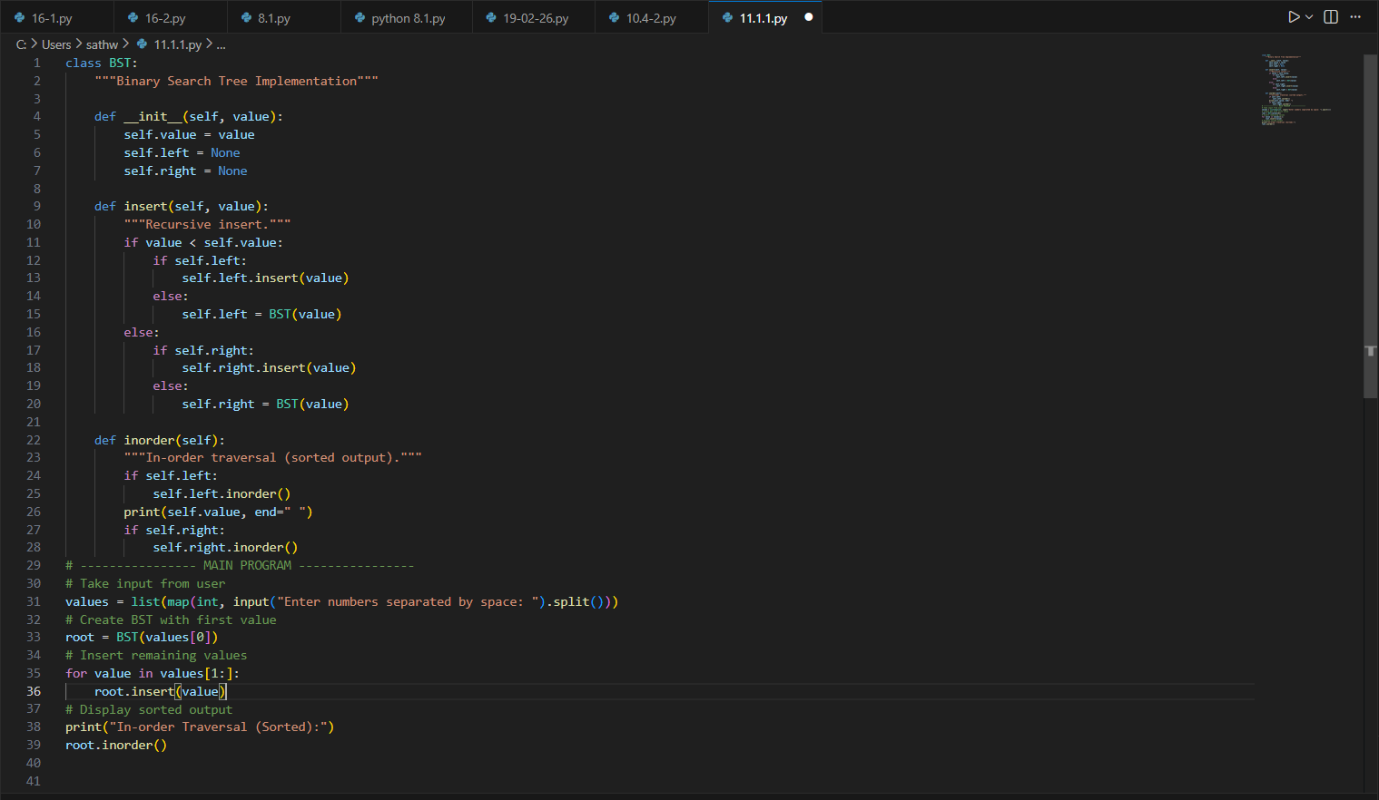
OUTPUT:
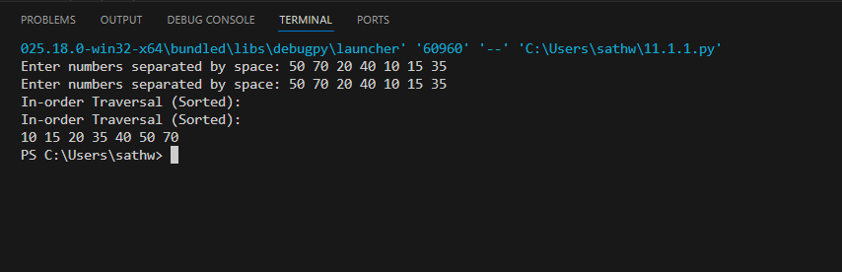
Task 4 – Binary Search Tree (BST)
Justification:
BST maintains elements in sorted order for efficient searching. It provides faster insert and search operations compared to linear structures.

Task Description #5 – Hash Table
Task: Use AI to implement a hash table with basic insert, search, and
delete methods.
Sample Input Code:
class HashTable:
pass
Expected Output:
• Collision handling using chaining, with well-commented methods.
PROMPT:
#Implement a Python Hash Table using chaining for collision handling with insert, search, and delete methods, custom hash function, proper documentation, and example usage.
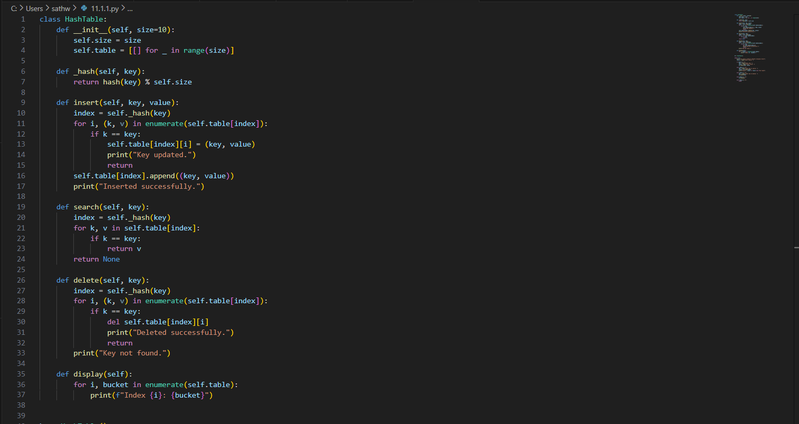
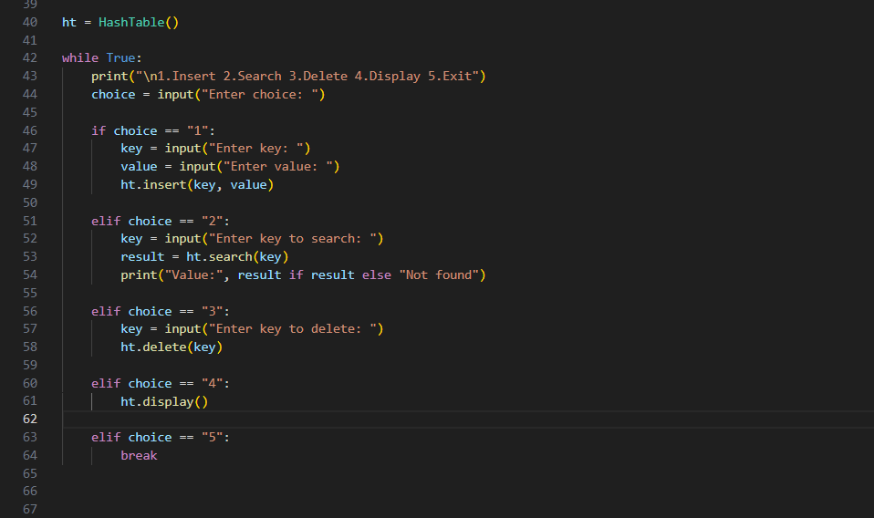
OUTPUT:
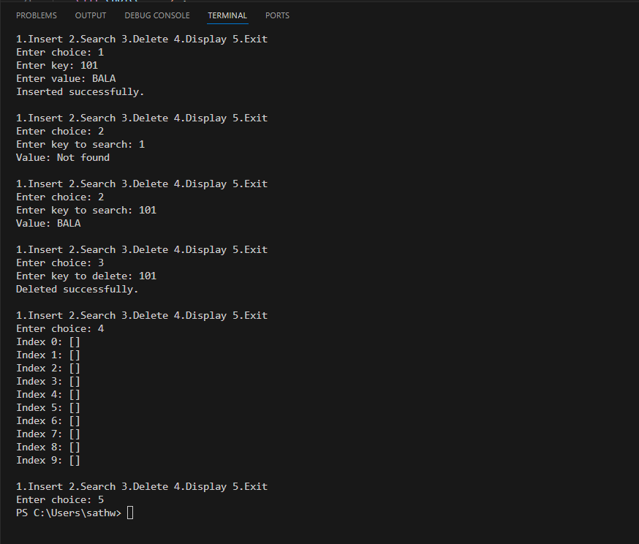
Task 5 – Hash Table
Justification:
Hash Table provides very fast lookup, insertion, and deletion using keys. It is ideal for applications requiring quick data retrieval.

Task Description #6 – Graph Representation
Task: Use AI to implement a graph using an adjacency list.
Sample Input Code:
class Graph:
pass
Expected Output:
• Graph with methods to add vertices, add edges, and display
connections.

PROMPT:
#Generate a Python Graph implementation using an adjacency list with add_vertex, add_edge, and display methods, including documentation, comments, and example usage.
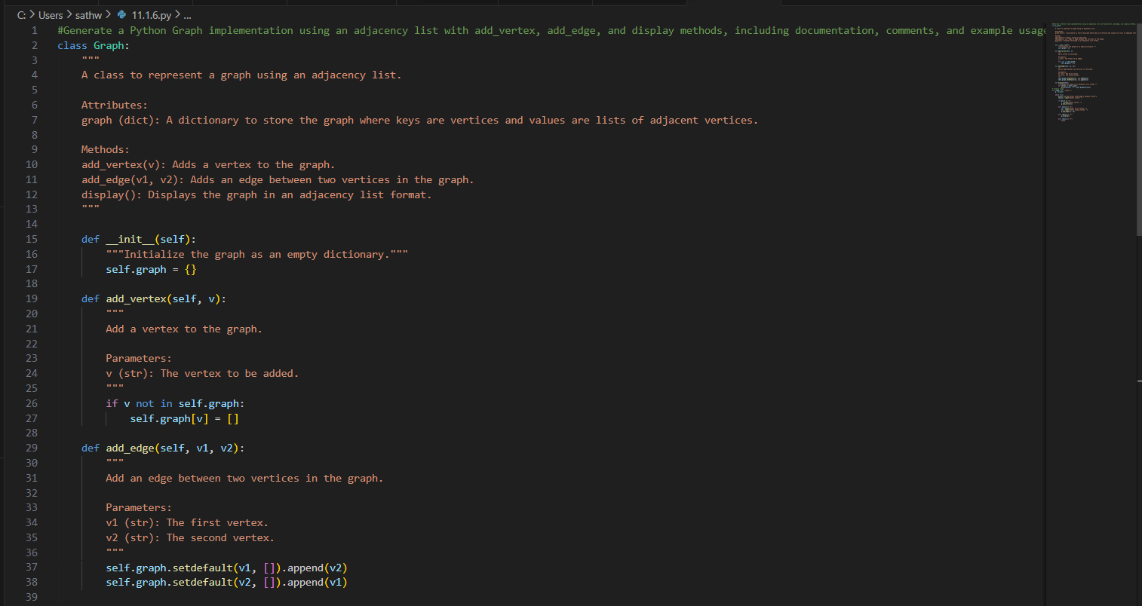
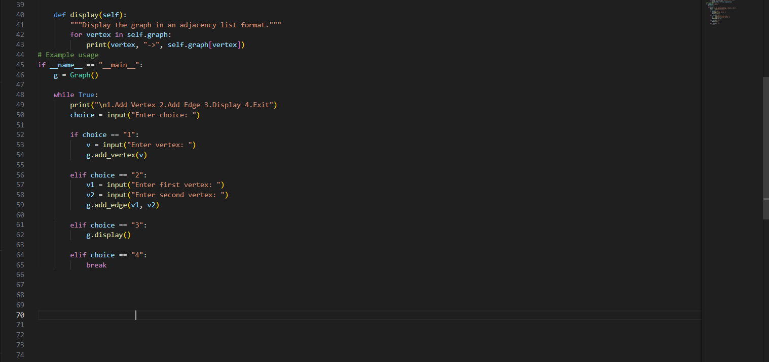

OUTPUT:
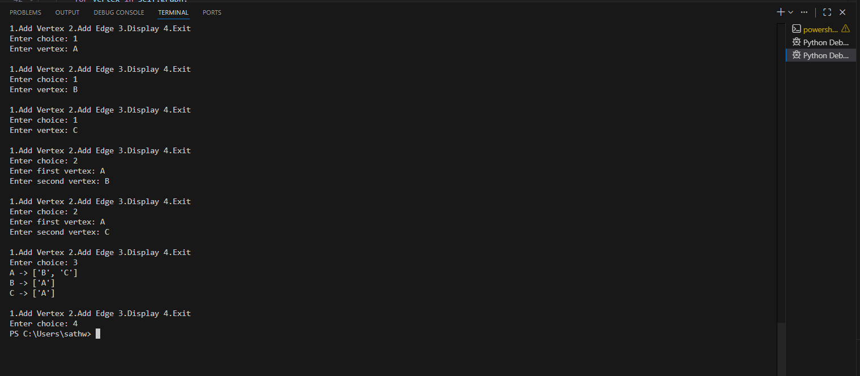

Task 6 – Graph
Justification:
Graph represents relationships between nodes using edges. It is suitable for networks, routes, and connected systems.

Task Description #7 – Priority Queue
Task: Use AI to implement a priority queue using Python’s heapq
module.
Sample Input Code:
class PriorityQueue:
pass
Expected Output:
• Implementation with enqueue (priority), dequeue (highest priority),
and display methods.
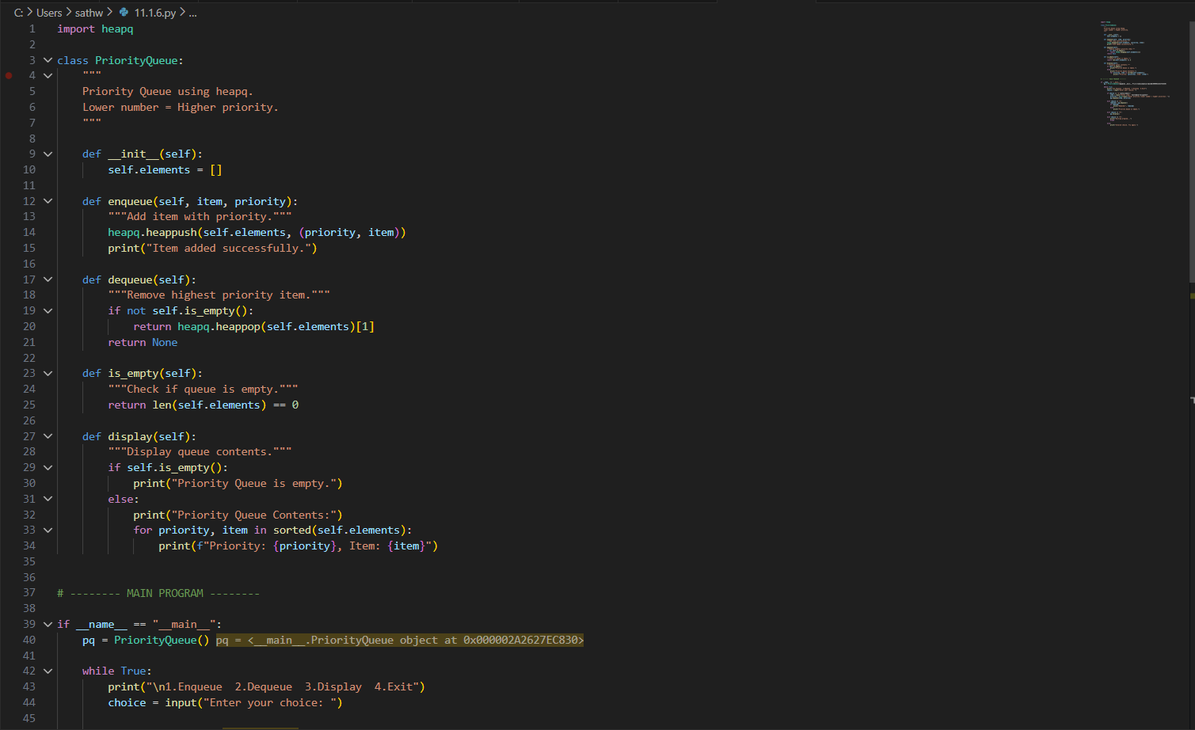
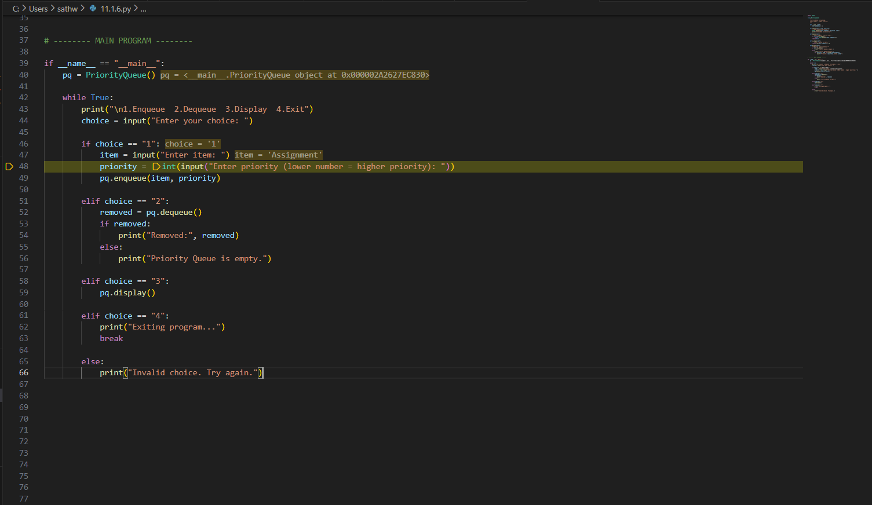
OUTPUT:
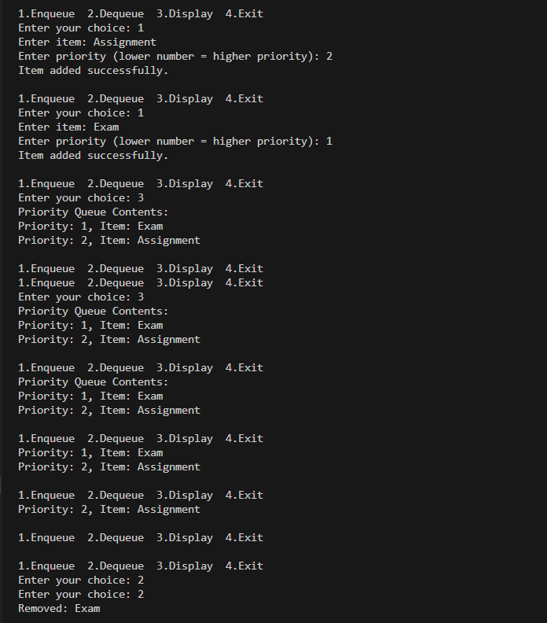
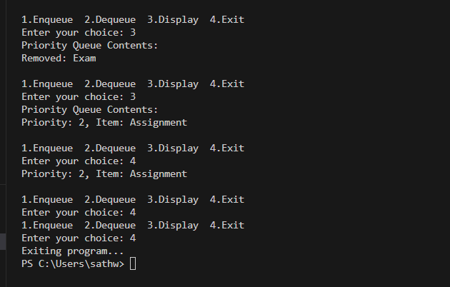
Task 7 – Priority Queue
Justification:
Priority Queue processes elements based on priority instead of order of arrival. It is used in scheduling and shortest path algorithms.

Task Description #8 – Deque
Task: Use AI to implement a double-ended queue using
collections.deque.
Sample Input Code:
class DequeDS:
pass
Expected Output:
• Insert and remove from both ends with docstrings.

PROMPT:
#Implement a Python Deque using collections.deque with insert_front, insert_rear, remove_front, and remove_rear methods, including proper documentation and example usage.

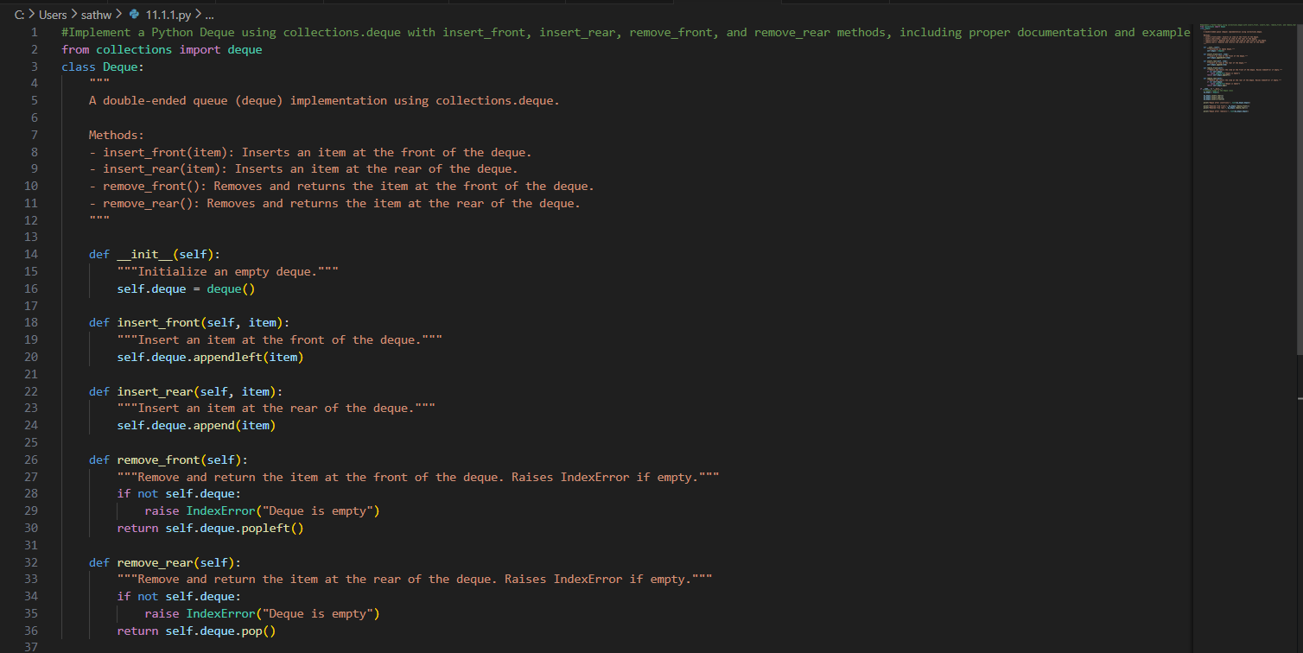
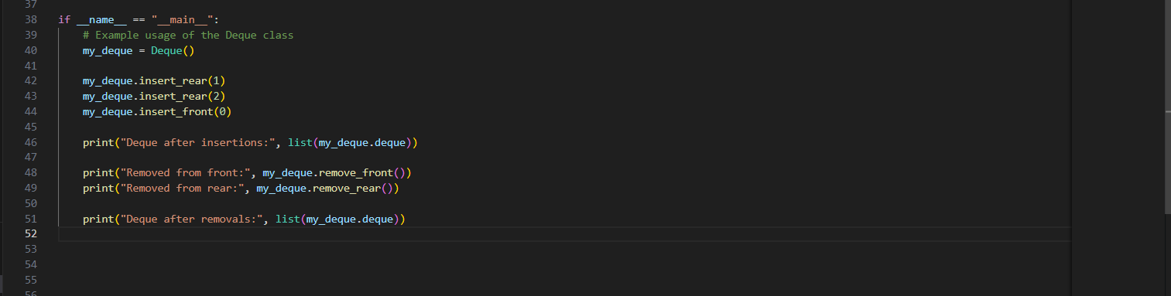

OUTPUT:
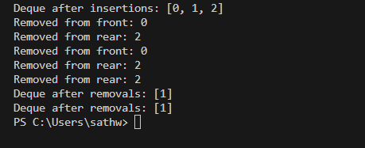

Task 8 – Deque
Justification:
Deque allows insertion and deletion from both ends. It is flexible and can work as both stack and queue.

Task Description #9 Real-Time Application Challenge – Choose the
Right Data Structure
Scenario:
Your college wants to develop a Campus Resource Management System
that handles:
1. Student Attendance Tracking – Daily log of students
entering/exiting the campus.
2. Event Registration System – Manage participants in events with
quick search and removal.
3. Library Book Borrowing – Keep track of available books and their
due dates.
4. Bus Scheduling System – Maintain bus routes and stop
connections.
5. Cafeteria Order Queue – Serve students in the order they arrive.
Student Task:
• For each feature, select the most appropriate data structure from
the list below:
o Stack
o Queue
o Priority Queue
o Linked List
o Binary Search Tree (BST)
o Graph
o Hash Table
o Deque
• Justify your choice in 2–3 sentences per feature.
• Implement one selected feature as a working Python program with
AI-assisted code generation.
Expected Output:
• A table mapping feature → chosen data structure → justification.
• A functional Python program implementing the chosen feature
with comments and docstrings.

PROMPT:
#Analyze the given campus system features, select the most appropriate data structure for each with justification, present the mapping in a table, and implement one feature as a documented Python program.
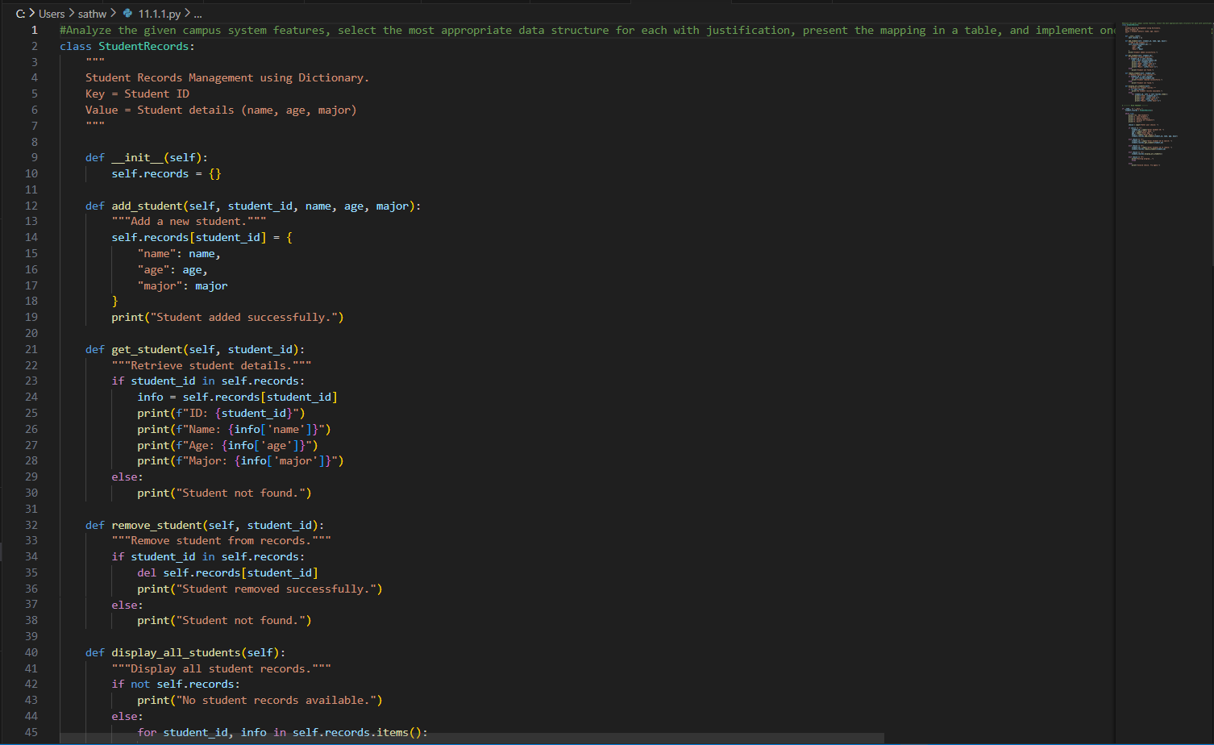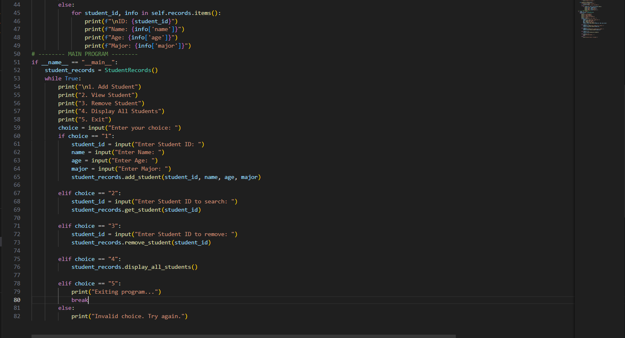
OUTPUT:
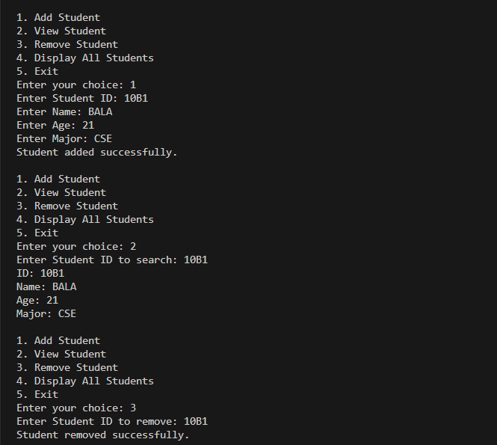
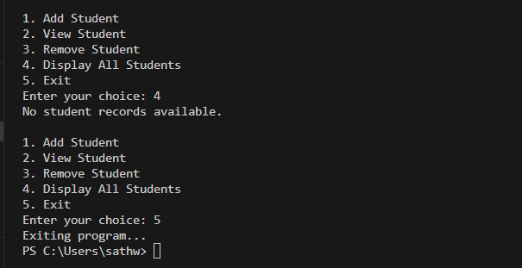
JUSTIFICATION TASK -9
1️⃣ Student Records – Dictionary
Stores data using unique ID for fast access.
2️⃣ Course Enrollment – List
Allows dynamic addition and removal of courses.
3️⃣ Faculty Information – Dictionary
Provides quick lookup using Faculty ID.
4️⃣ Campus Events – List
Stores multiple events and supports easy updates.

Task Description #10: Smart E-Commerce Platform – Data Structure
Challenge
An e-commerce company wants to build a Smart Online Shopping System
with:
1. Shopping Cart Management – Add and remove products
dynamically.
2. Order Processing System – Orders processed in the order they are
placed.
3. Top-Selling Products Tracker – Products ranked by sales count.
4. Product Search Engine – Fast lookup of products using product ID.
5. Delivery Route Planning – Connect warehouses and delivery
locations.
Student Task:
• For each feature, select the most appropriate data structure from
the list below:
o Stack
o Queue
o Priority Queue
o Linked List
o Binary Search Tree (BST)
o Graph
o Hash Table
o Deque
• Justify your choice in 2–3 sentences per feature.
• Implement one selected feature as a working Python program with
AI-assisted code generation.
Expected Output:
• A table mapping feature → chosen data structure → justification.
• A functional Python program implementing the chosen feature
with comments and docstrings.

PROMPT:
#Generate a menu-driven Python program for an Order Processing System using a Queue (FIFO) with user input support in VS Code, including place_order, process_order, and display_orders methods, proper documentation, and continuous loop until exit.
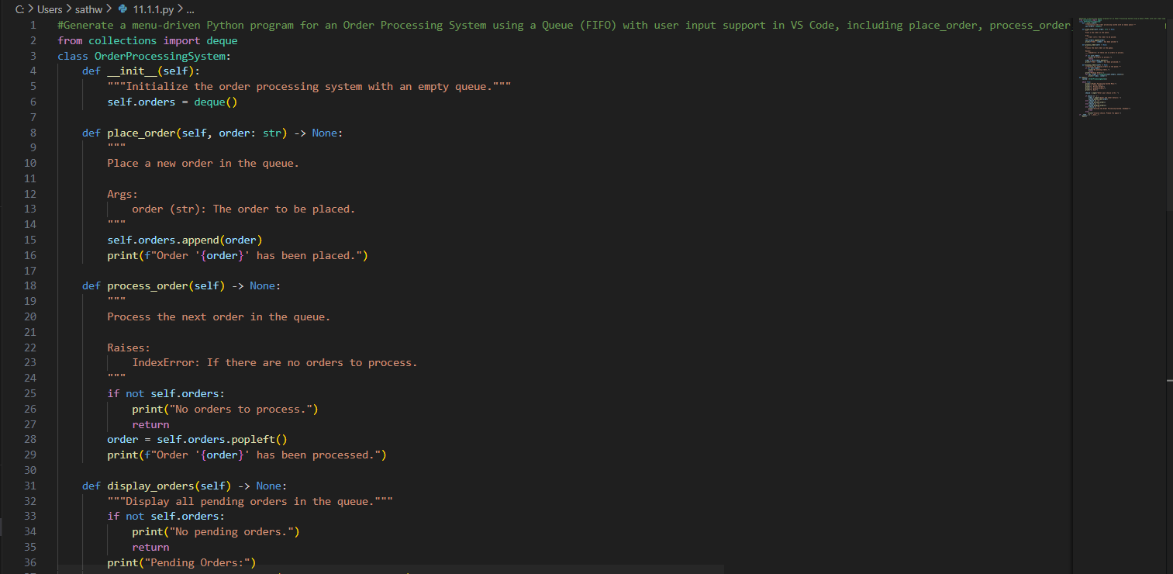
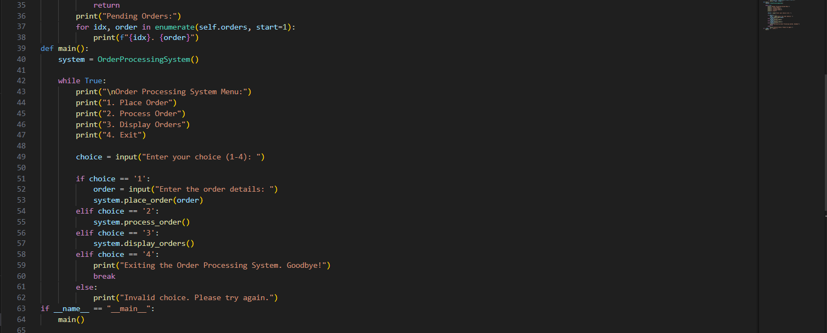

OUTPUT:
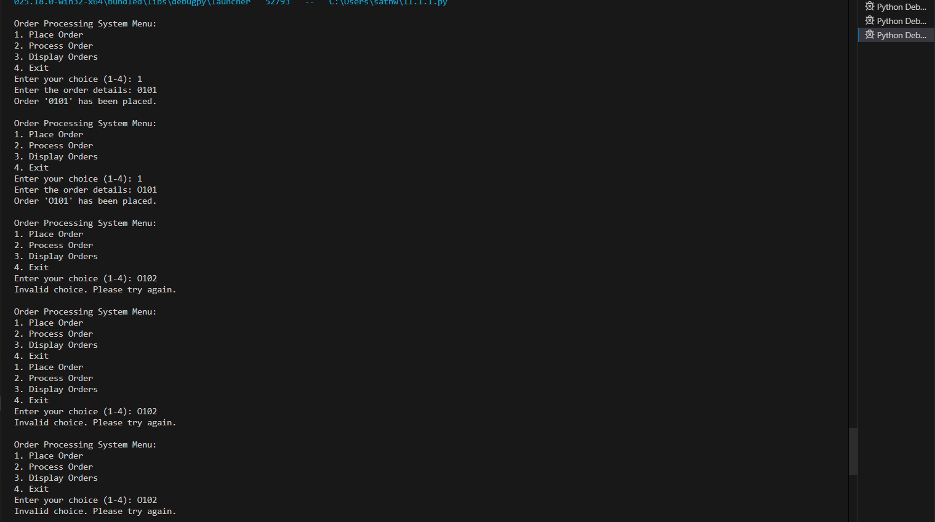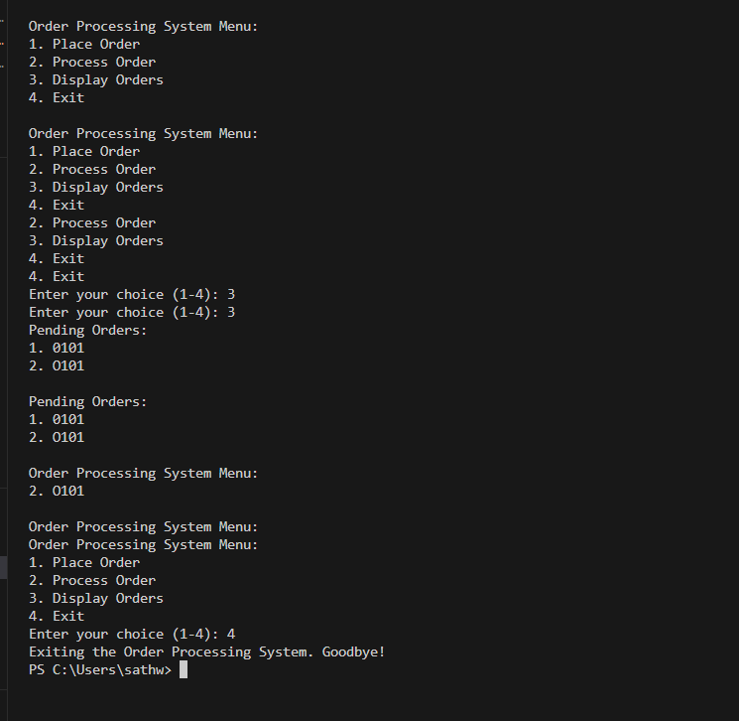
JUSTIFICATION:

Task 10 – Data Structure Mapping
1️⃣ Shopping Cart – Linked List
Allows dynamic add/remove of products easily.
2️⃣ Order Processing – Queue
Processes orders in FIFO order.
3️⃣ Top-Selling Products – Priority Queue
Retrieves highest selling products first.
4️⃣ Product Search Engine – Hash Table
Provides fast lookup using product ID.
5️⃣ Delivery Route Planning – Graph
Represents warehouses and locations as connected nodes.

